Scope
Theme assigned to us is Courier Service. Machines can be trained to perform a task more accurately. So, as the name suggests the major scope of the theme is to reduce man labor and increase efficiency in the parcel delivery.
The parcels to be delivered are identified and delivered at accurate location.
The conclusions can be applied not only in the parcel delivery but the scope can be widened.
Security systems can be installed, task can be divided into multiple robots.
During Calamity, such applications can be implemented through other bots.
Application in fields like fire extinguishing, ambulance, other at home services.
At small scale, indoor delivery systems can be developed. Eg. Inside hotels.
Data can be collected to train the robot for future
Reduces man labour and task is performed more efficiently for a well developed solution.
Applications and scope of the theme: “Parcel Delivery”

Building Module
Various components of the kit can be classified as follows:
1) Raspberry Pi B+ and its accessories:
- Raspberry Pi is the major component for developing the solution as it provides us interface to program the robot and used to connect the camera and other accessories.
- Micro SD card: For loading the file and saving the progress.
- Wi-Fi Dongle: To connect the robot wirelessly with the laptop.
- Power Bank: To power the raspberry pi module.
2) Mechanical System:
- Chassis, Wheels, BO motors, nuts & bolts and other necessary components are used for creating a moving robot and a structure to mount the accessories.
3) L293D Motor Driver IC:
- This IC is necessary to enable motors operation as raspberry pi cannot supply sufficient current for proper operation from GPIO pins.
4) USB Webcam:
- USB webcam is major component for path traversal. Color of nodes and black line are detected using video analysis of webcam.

Camera
Camera will play a major role in the environment sensing. Camera will be used for the following tasks:

- Path Traversal: The shortest path algorithm (we are planning to use Dijkstra Algorithm) which will provide the information of the node to be traversed, will be effectively implemented by the black line following through video processing.
- Traffic Signal Detection: Though the code already has the information of the nodes where traffic is possible but exact status will be known through color detection through the camera in real time.
- If traffic is red, sometimes it is better to wait for 30sec as other paths may also have traffic.
- So, such decision will be made depending upon the traffic state at second shortest path.

- Correction Mechanism: It’s not possible for any robot to move straight even after calibration and PWM, so we may use camera as sensors array to detect and correct its orientation for proper path traversal on the arena.
- Correction is important, otherwise bot will move in wrong direction once it started following the wrong path.
- Alternatively, we could have used color sensors for the detection of traffic signal and white line sensor array (if it were provided) for path traversal, as video processing will involve many hardships due to less memory of Raspberry pi.
- The information of motion and direction of motion can also be provided through python coding and but this will not effectively move the robot unless correction mechanism is involved.
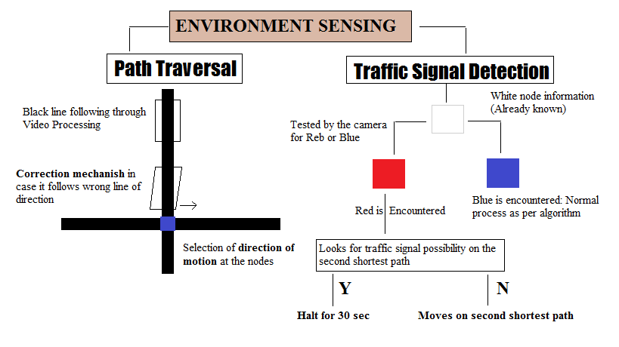

Navigation Scheme
- Path traversal will involve video processing during run time to follow the black line.
- Just like sensors array, we are considering few points on the frame (depending upon testing), for measuring high or low range of pixel values as shown in figure.

Case1: When the robot deviates Case2: When the robot suffers Case3: When the robot deviates
towards right no deviation in direction towards left
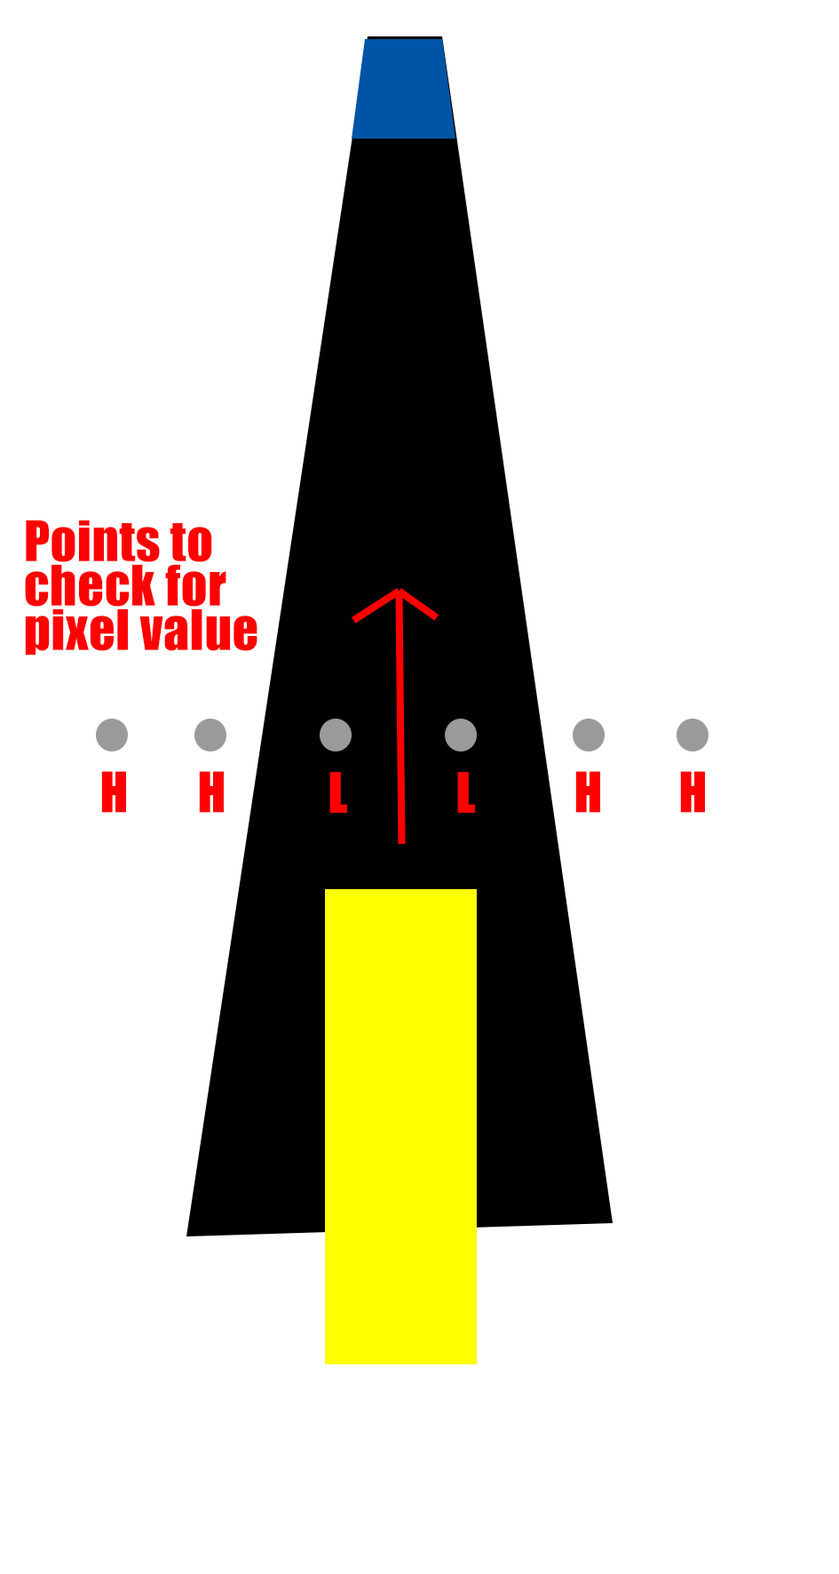
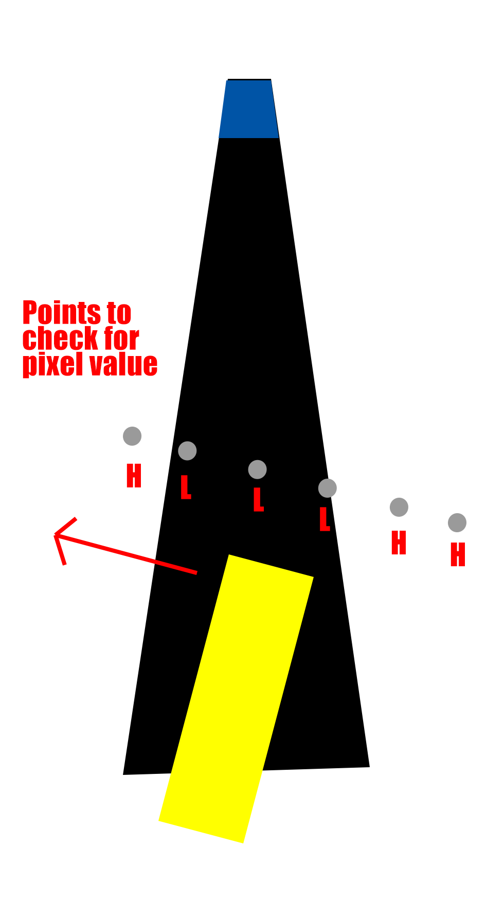
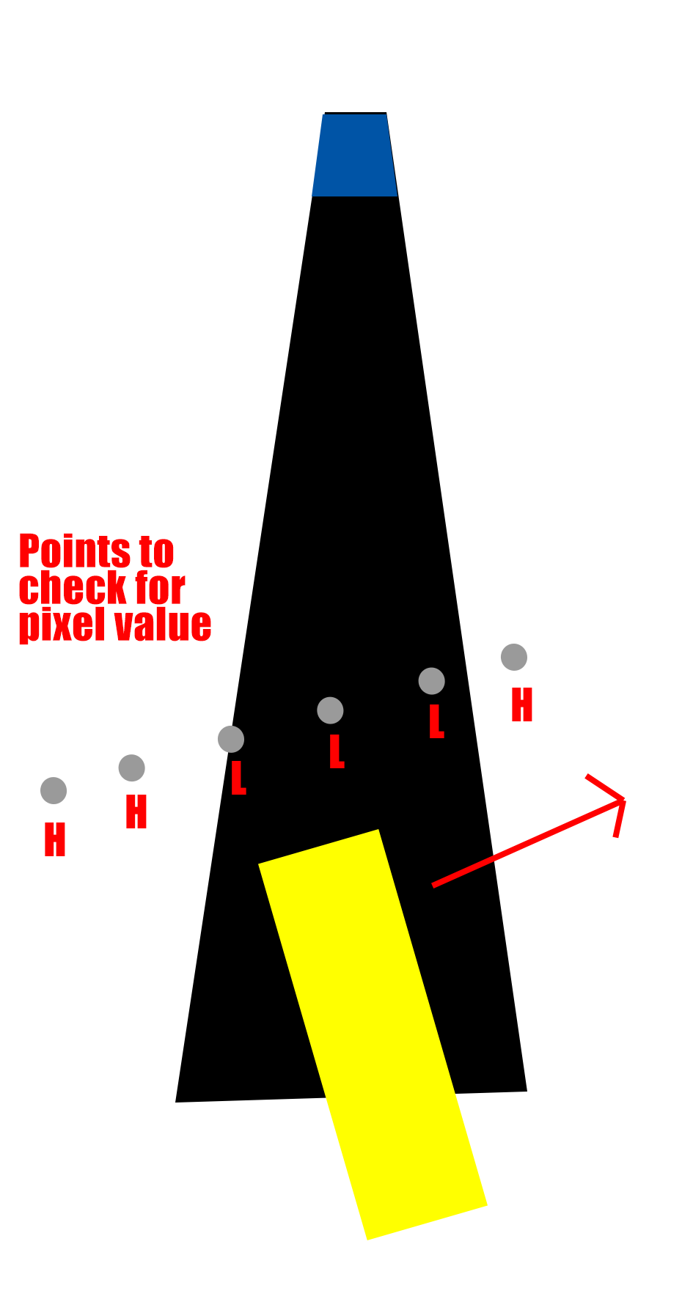

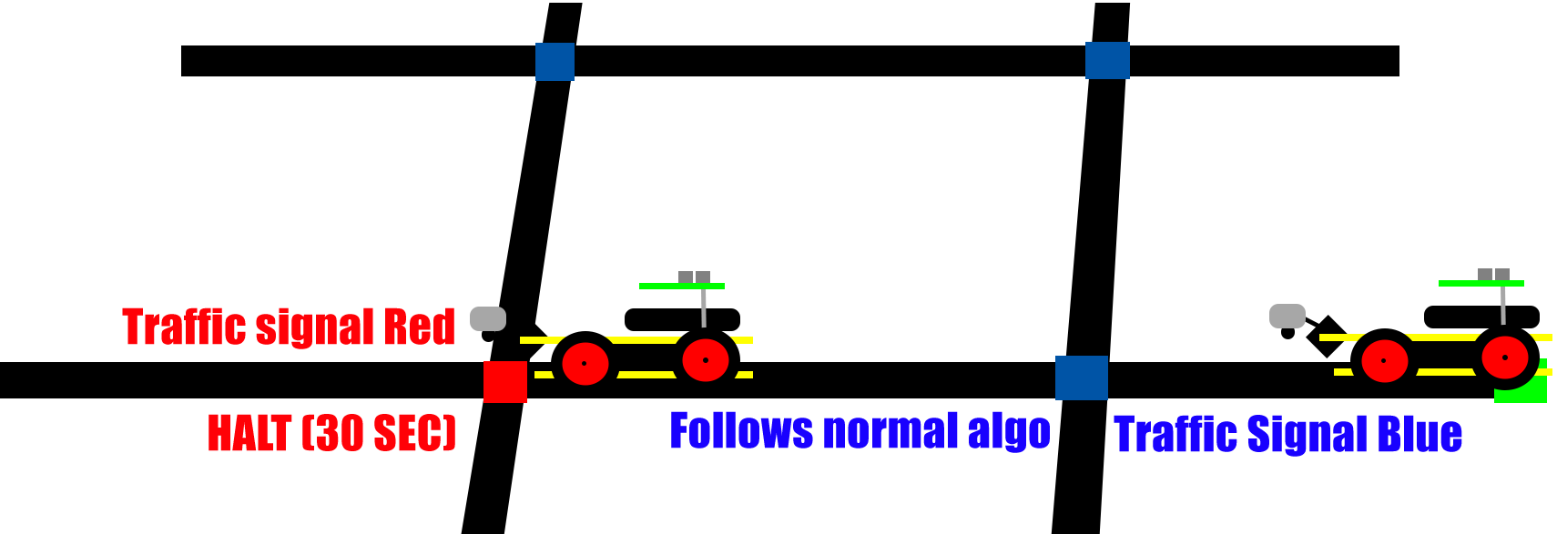
- When traffic signal is encountered robot will make decision of waiting of moving back depending upon traffic signal on other paths.

- From green start the robot traverse in the Warehouse zone from company pickup nodes 1 to 6.
- Now it will start traversing in the way that the next destination node is nearest from current node.

Testing your knowledge (Based on theme and rulebook)

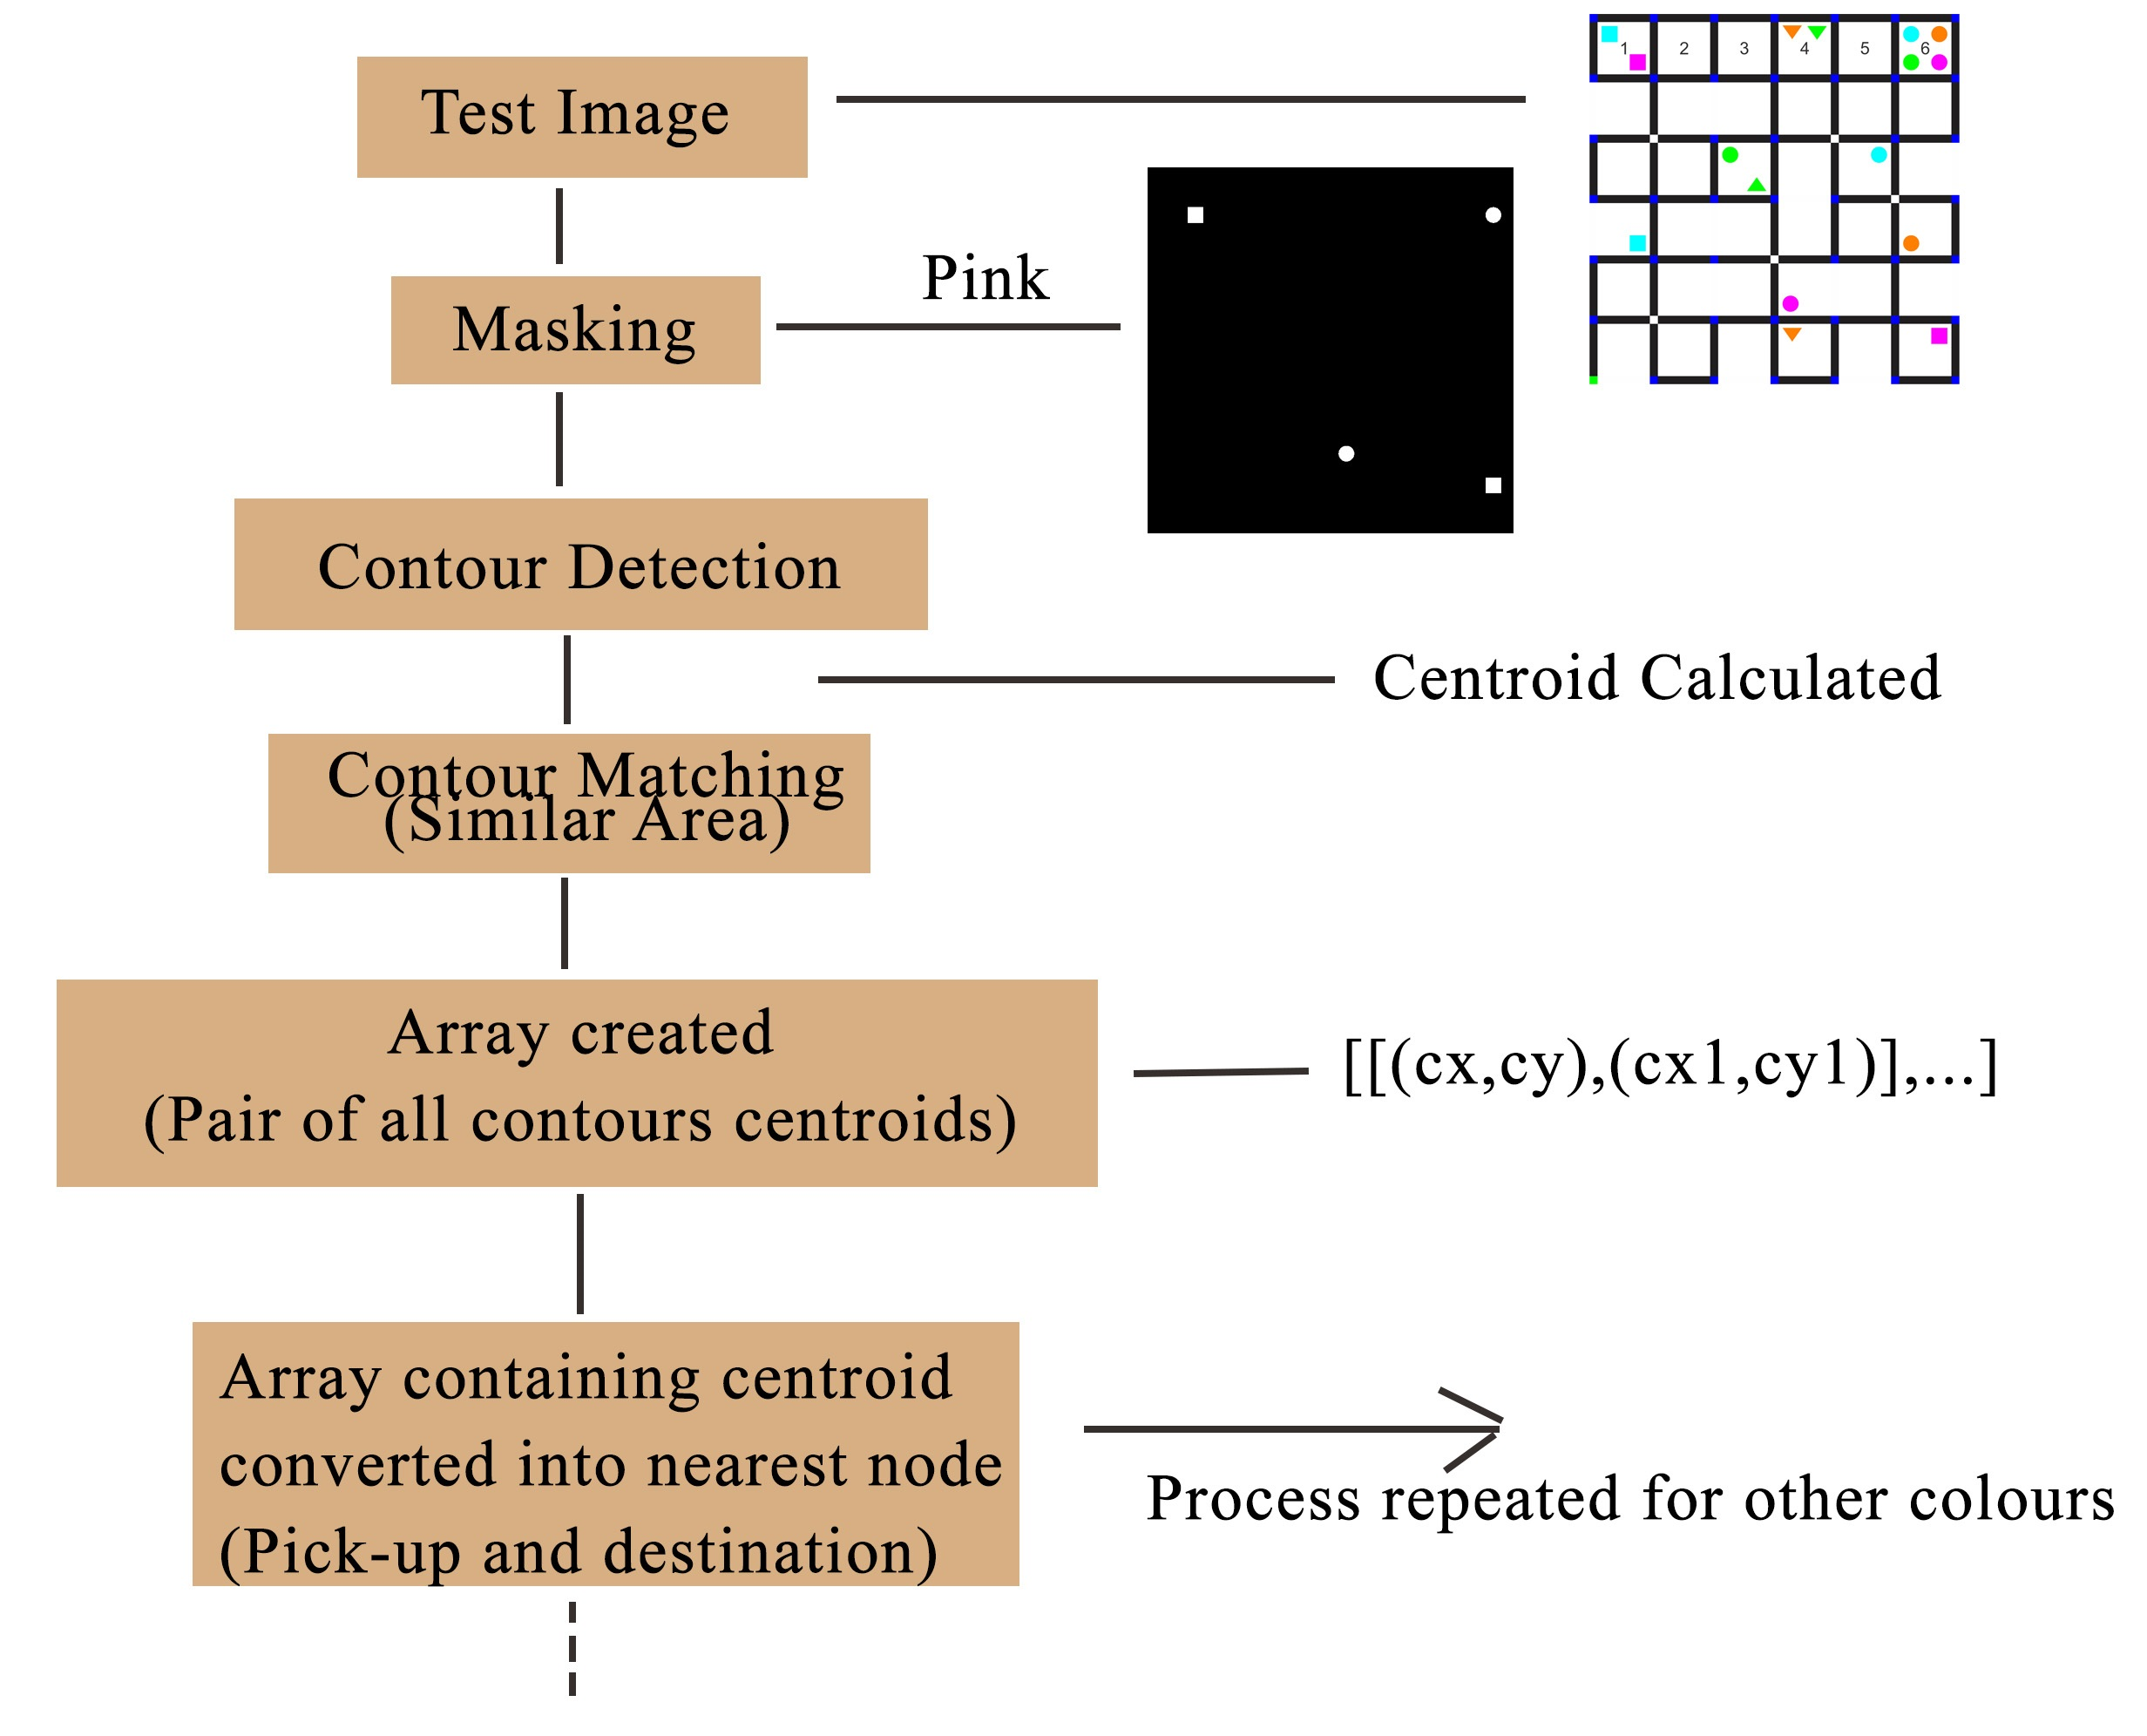

- Before the traversal various preprocessing functions will create list of nodes on which the robot has to traverse.
- This involves processing test image i.e. masking, threshing and contour operation to extract all the necessary information from the image as shown in the diagram.
- The function is called 4 times for all different colors.
- The list of array has pair to two nodes. First node: Warehouse zone pickup point
Second node: Destination node

The start point, end point and the possibility of junction being red is already known from the pre-processing of given test image. Robot will take the following course of action.

Step 1: Calculate the shortest path from the previous node.
Step 2: As we already have the information of white node. It will search for presence of white node on that path.
Step 3: If there is any white node present, the algorithm will decide to halt and wait for 30sec otherwise it will follow this shortest path.

(Note: As the bot takes 2-3 seconds to cover a link, so it is always beneficial to choose the shortest path from the previous node rather than waiting for 30sec. So, depending on testing, we may amend the algorithm for the condition of halting.)

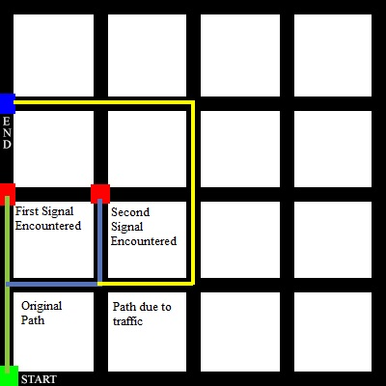

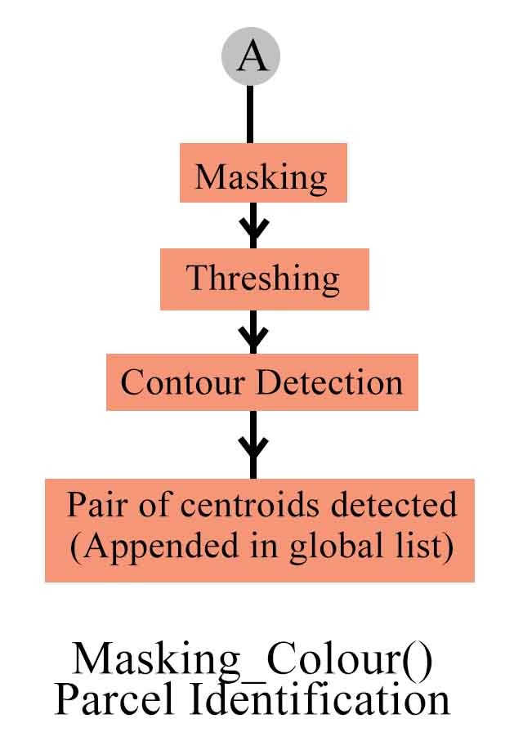
A-lgorithm Analysis
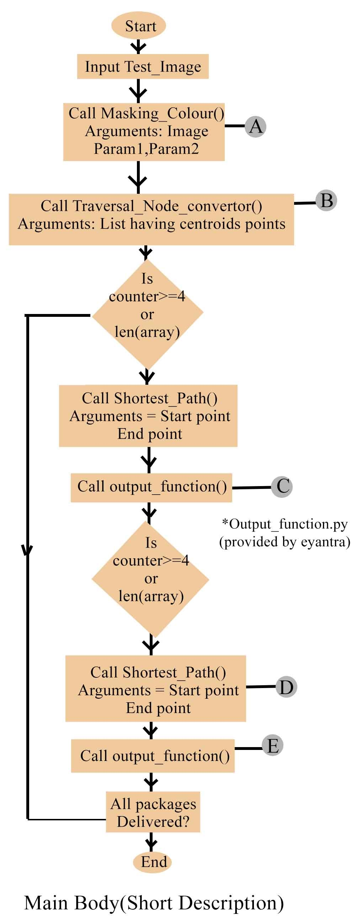

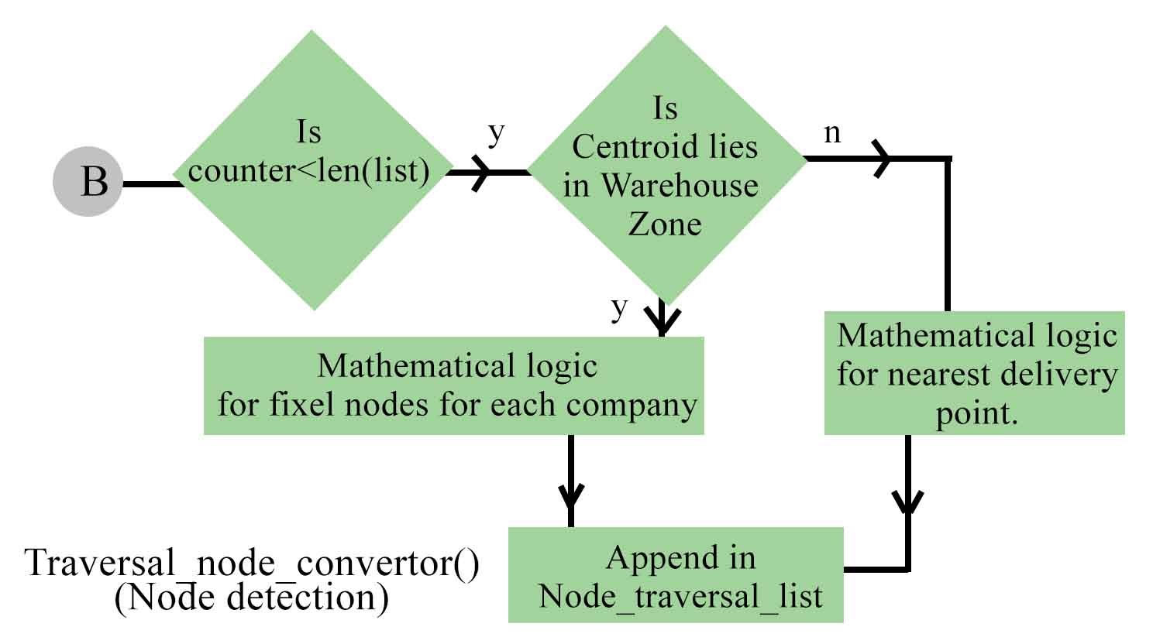
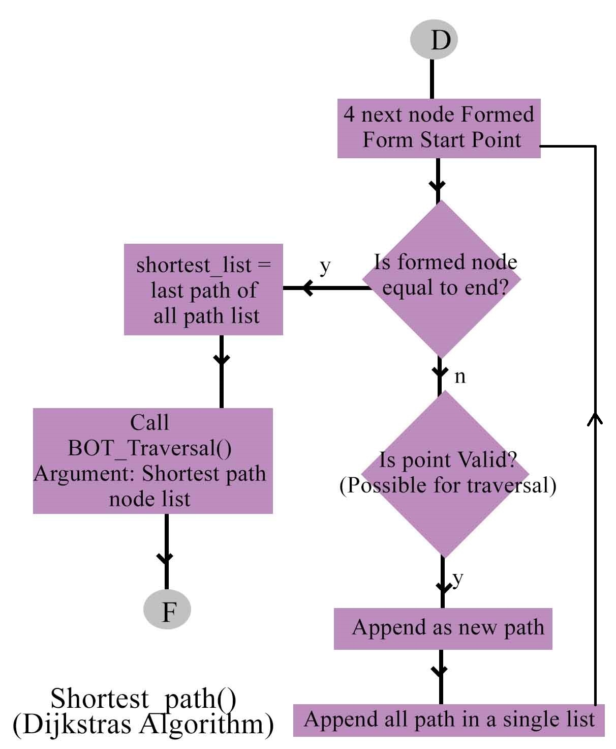

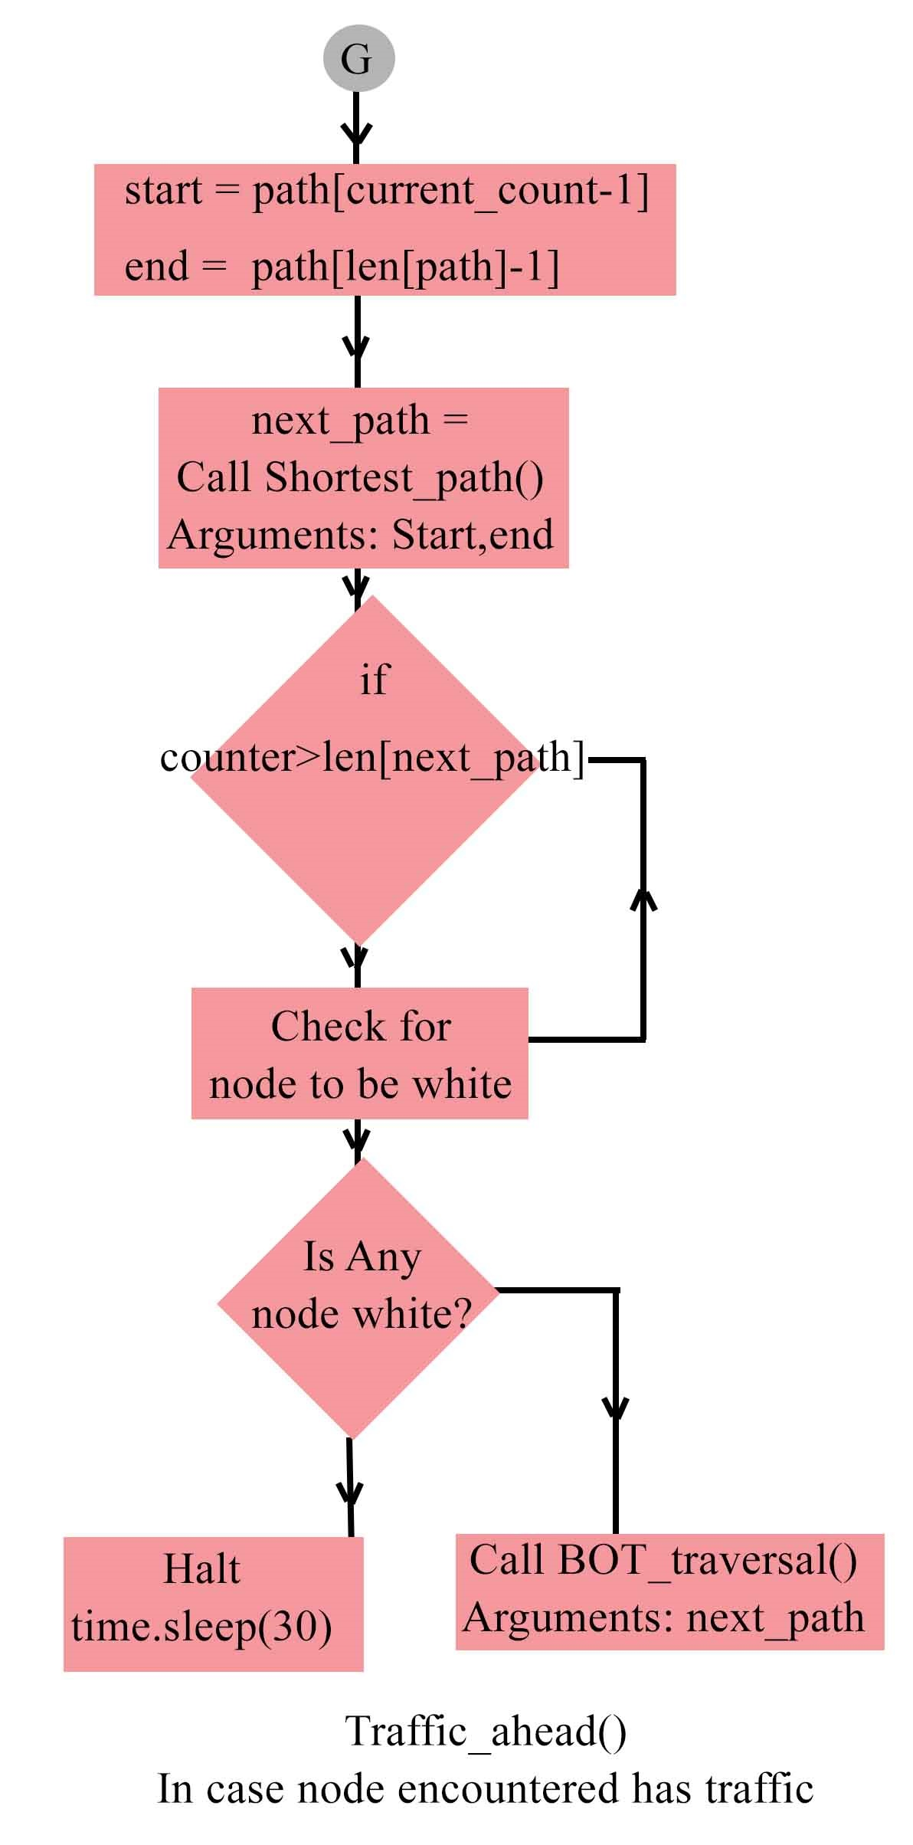
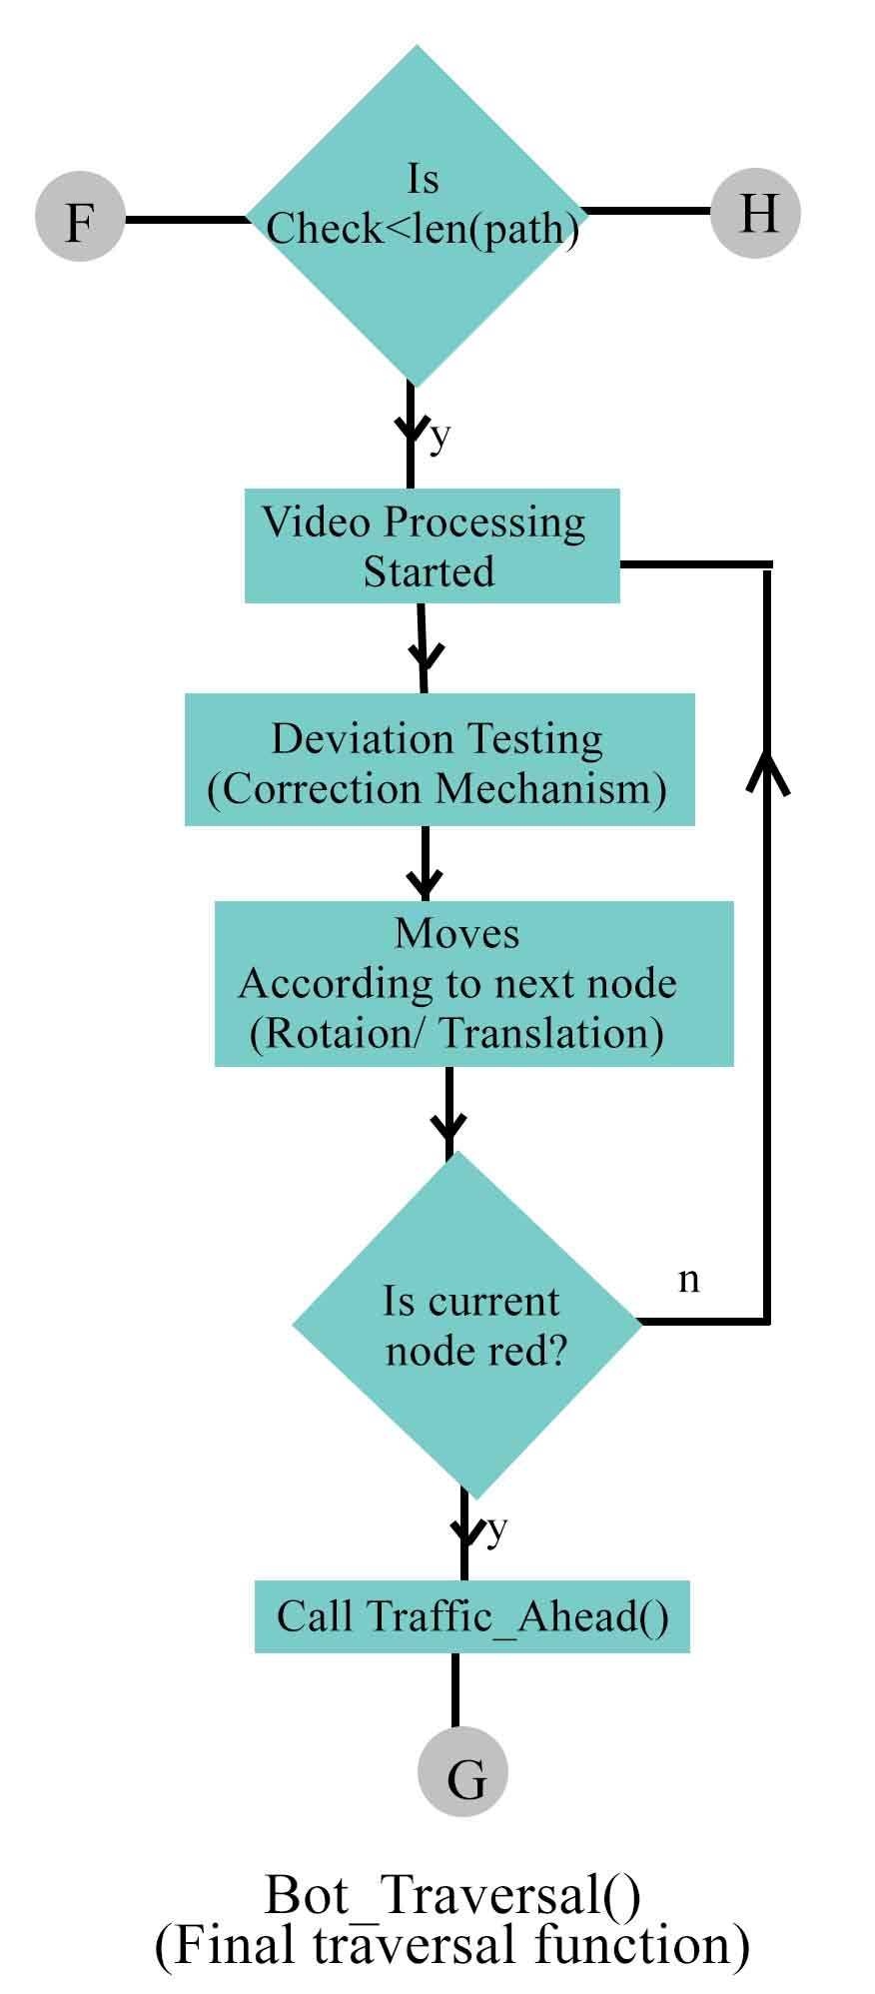

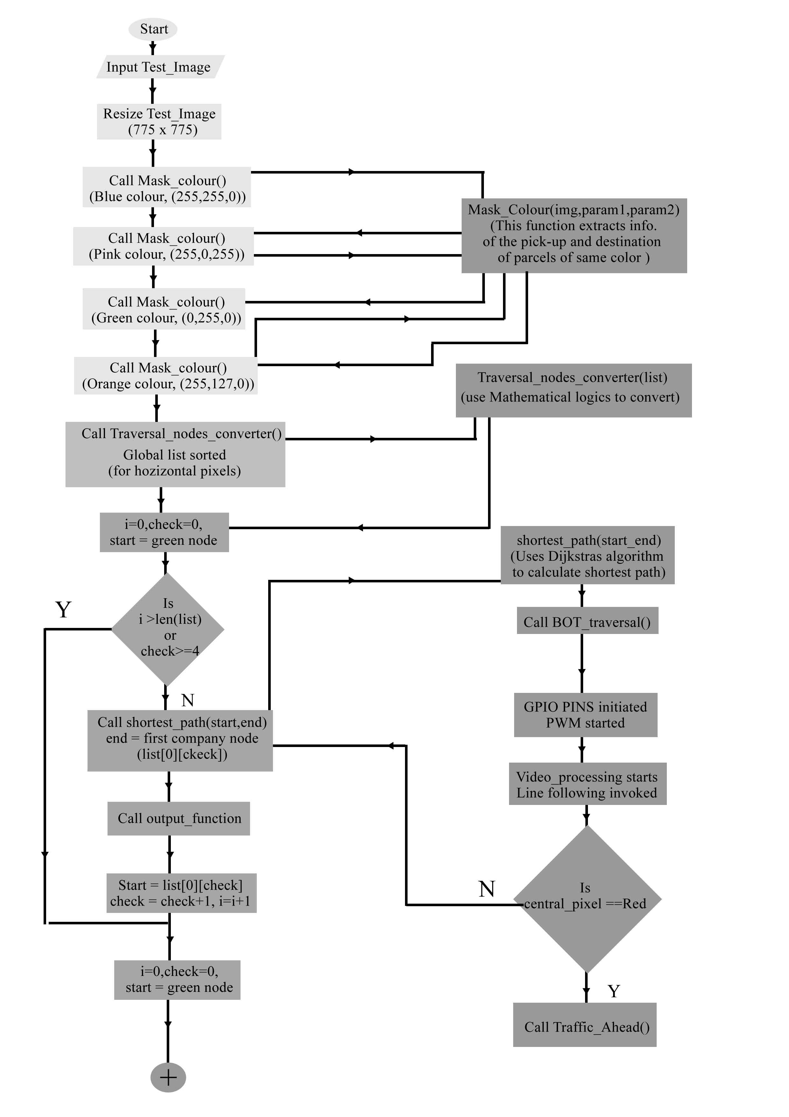
Data flow of the algorithm

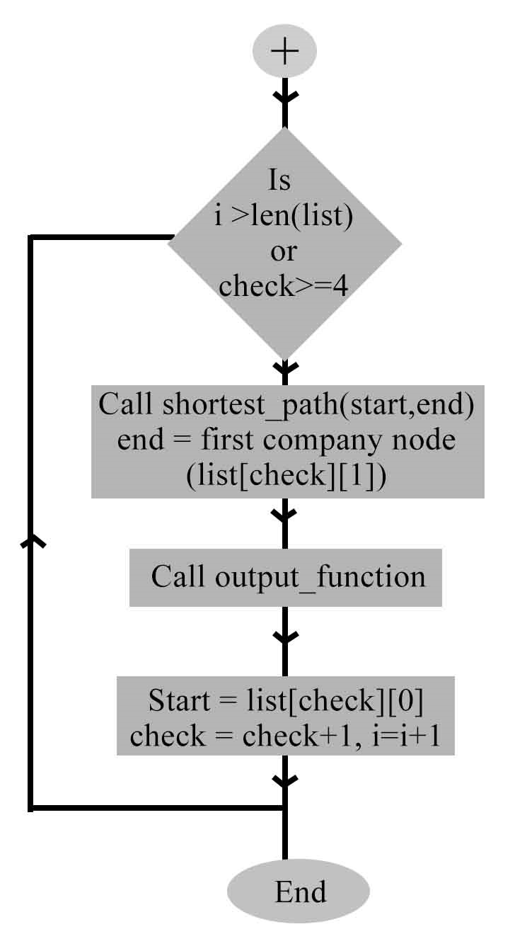

Main Function(Explained with function Calling)
Challeges
Major Challenges:
1) Efficient video processing: This is the major challenge as processing on the video frames requires more memory. We have to find the solution of using 512MB RAM of Raspberry Pi B+ effectively to get appropriate frame rate even after lengthy processing inside video loop.

2) Variable Light Intensity: Results of real-time image processing are highly dependent on light because it changes pixel values. We have to text the results on various light intensities to set range for generalization of the code.

3) Traffic Signal Decision Making: This is tricky as this concept is making the robot more human. So, the algorithm which we have proposed may need lot of improvisations for before presenting on the arena.

4) BOT motion and Correction Mechanism: As no two motors are same, so robot may show varied motion behavior from expected. This will need a fully tested and optimized code for correction mechanism.

5) Time and delay settings: while applying PWM to the raspberry pi with RPi.GPIO the proper delays are necessary otherwise the loop will crash or motors will show improper behavior.

6) Code Optimization: optimization of every function in the code is necessary to increase the frames in video processing and to effectively use the memory capability of Raspberry Pi.

